**Project Details**

|  |  |
| --- | --- |
| **Document Status** | Approved for Implementation |
| **Project Name:** | Fortum MAS9 Upgrade |
| **Account:** | Fortum |
| **Client Name:** | Fortum |
| **Delivery Manager/ Email ID:** | Shrikanth S. V <shrikanth.sunkum@wipro.com> |
| **Project Manager / Email ID:** | Nihar Jain <nihar.jain@wipro.com> |
| **Solution Architect** | Santosh Bade <santosh.bade@wipro.com> |
| **Client Contact Information:** | Kim Danska <Kim.Danska@fortum.com> |
| Jussi Kosenius <jussi.kosenius@fortum.com> |
| Jouko Lehtinen <Jouko.Lehtinen@fortum.com> |
| Christian Grannes christian.grannes@partners.fortum.com |

Integration

|  |  |  |  |  |
| --- | --- | --- | --- | --- |
| Santosh Bade 23/09/2024 |  | Matti Turunen 10/12/2024 |  | Lehtinen Jouko 12/12/2024 |
| **Prepared by/Date** |  | **Reviewed by/Date** |  | **Approved by/Date** |

**Revision History**

|  |  |  |  |  |  |
| --- | --- | --- | --- | --- | --- |
| **Version (x.yy)** | **Date of Revision** | **Description of Change** | **Reason for Change** | **Affected Sections** | **Approved By** |
| 1.0 | 23/09/2024 | Initial Draft version | First Draft |  |  |
| 1.1 | 06/12/2024 | Addressed comments of Matti | EA Review Feedback |  |  |
| 1.2 | 10/12/2024 | Addressed comments of Matti from second review | Approved for Implementation |  | Jouko Lehtinen |
|  |  |  |  |  |  |
|  |  |  |  |  |  |
|  |  |  |  |  |  |
|  |  |  |  |  |  |
|  |  |  |  |  |  |

**Affected Groups**

|  |
| --- |
|  |
|  |
|  |
|  |

**List of Reference Documents**

|  |  |
| --- | --- |
| **Name** | **Version No.** |
| 1. |  |
| 2. |  |
| 3. |  |
| 4. |  |

**Table of Contents**

1 Introduction 5

1.1 Overview 5

1.2 Scope 5

1.3 Out-Scope 6

1.4 References 6

1.5 Definitions, Acronyms and Abbreviations 6

2 System Overview 8

3 Business Requirements 9

3.1 Functional Requirements 9

3.2 Non-Functional Requirements 9

4 Architectural Guidelines 10

4.1 Architectural Principles 10

4.2 Potential Reusability 11

4.3 Architectural Decisions 11

4.3.1 MAS9 upgrade 11

4.3.2 Non-Prod OCP Cluster 11

4.3.3 Disaster Recovery 11

5 Business Architecture 12

6 Current Solution 13

7 Target Solution 16

7.1 Solution Overview 16

7.2 Technology Overview & Architecture 17

7.3 Logical Architecture 21

7.4 Network Architecture 24

7.5 Application Architecture 25

8 Information Flow 27

8.1 MAS Manage Modules 27

8.2 Integrations 29

9 Deployment Overview 31

9.1 Deployment View 31

9.2 Environment View 33

9.2.1 Vanilla URLs 35

9.2.2 DEV URLs 35

9.2.3 Stage URLs 35

9.2.4 Prod URLs 35

9.3 Infra Specification 36

9.3.1 Application Infra 37

OCP Cluster Machine Types - 37

9.3.2 Database Infra 38

10 Cutover & Migration 40

11 Network & Security 42

11.1 Network View 42

11.2 Security View 43

11.2.1 Azure Front Door & WAF 43

11.2.2 Azure Private Link 43

11.2.3 Azure Firewall 43

11.2.4 Authentication 43

11.2.5 Authorization 44

11.2.6 Encryption 44

12 Service Overview 45

12.1 Support Model 45

12.2 Service Level Agreements 45

12.3 Maintenance and Patching/Release Process 46

12.3.1 Azure RedHat OpenShift 46

12.3.2 Maximo Application Suite - 48

12.4 Change Management 49

12.5 Backup Schedule 49

12.6 Disaster Recovery 51

12.6.1 Application High-Availability on ARO 52

12.6.2 Database High-Availability on ARO 52

12.6.3 DR Testing 53

12.7 Monitoring Solutions 53

12.7.1 Azure RedHat OpenShift Platform Monitoring 53

12.7.2 Maximo Application Suite Monitoring 54

13 Decommissioning 55

14 Appendix 58

# Introduction

## Overview

Fortum is using IBM Maximo as an Asset and Work Management system, and it is a critical application which supports Fortum’s Maintenance operations of all production related assets. Fortum Maximo is currently on version 7.6.1.2.

On 12 April 2022, the end of support for all IBM Maximo Asset Management 7.6.1.x and compatible versions of products, including industry solutions and add-ons, was announced with IBM Announcement Letter 922-024. Effective 30 September 2025, fixes, patches, and telephone support are no longer provided for Maximo 7.6.1.x and its corresponding components and add-ons of the same version. From now until that date, additional fix packs are delivered to address critical defects, security vulnerabilities, and currency updates. The path forward for all Maximo EAM customers is to trade-up to the IBM Maximo Application Suite. Hence, Fortum Maximo will be upgraded from Maximo 7612 to Maximo Application Suite 9 (MAS9)

As part of Fortum MAS9 upgrade project, there is a critical need to upgrade the existing Maximo 7.6.1.2 system to MAS 9.x. The primary goal of this upgrade is to keep the Maximo solution supported by product vendor. Given that version 7.6.1.2 is no longer supported, this upgrade is essential to prepare for the anticipated end of life for the 7.6.x series in September 2025. This strategic move is not only about maintaining operational continuity but also about leveraging the latest advancements in the MAS platform to enhance system efficiency and leverage additional features.

## Scope

This upgrade, scheduled over a 9-month period, will commence with a de-customization of the existing version, followed by the establishment of three MAS 9 environments, concluding with a one-month hyper care phase. It is important to note that this upgrade is designed to retain existing functionalities and integrations without alterations.

The upgrade is pure technology upgrade apart from the pre-agreed de-customization activities in which java custom code will be replaced with Maximo Automation Scripts or Maximo Configuration and unnecessary customization will be removed from the system.

Existing Maximo 7.6.1.2 is upgraded to MAS9 on technical level only. Functional content remains unchanged. If minor changes into functionality are required, they will be designed, implemented and documented separately.

The scope of this upgrade encompasses a series of high-level activities, outlined as follows:

* Infrastructure Set-up for Maximo 7.6.1.2 Environment
* De-customization of Maximo 7.6.1.2 as per analysis report
* Infrastructure Setup for 3 MAS 9 environments
* Upgrade Maximo 7.6.1.2. to MAS 9 environments
* Realign the integrations with MAS 9
* Maximo Mobile configuration and migration from Maximo 7612 to MAS9
* Report cleanup and migration
* Test case re-alignment, End to End testing, Performance Testing on MAS 9
* Training document preparation and execution
* Production Cutover, Go-live and warranty support

## Out-Scope

The following activities are identified as out of scope in the execution of this project:

* New Enhancements or change in existing business processes/functionality.
* New Interface Development or any changes any existing integrations apart from retrofit.
* Data Migration from external systems to Maximo or vice-versa

## References

|  |  |  |
| --- | --- | --- |
| **Sr No** | **Document Name** | **Link** |
| 1 | OCP & MAS Monitoring reference link | <https://learn.microsoft.com/en-us/azure/azure-monitor/essentials/prometheus-grafana> |
| 2 | ARO Creation Reference link | [https://developers.redhat.com/articles/2022/03/04/create-azure-red-hat-openshift-cluster-less-5-minutes#](https://developers.redhat.com/articles/2022/03/04/create-azure-red-hat-openshift-cluster-less-5-minutes) |
| 3 | IBM MAS Architecture Reference link | <https://www.ibm.com/docs/en/mas-cd/continuous-delivery?topic=availability-logical-architecture> |
| 4 | IBM MAS Documentation Link | <https://www.ibm.com/docs/en/mas-cd/continuous-delivery?topic=models-maximo-application-suite-architecture> |
| 5 | MAS Deployment options on Azure | <https://techcommunity.microsoft.com/t5/azure-migration-and/ibm-maximo-application-suite-migration-and-modernization-with/ba-p/4123838> |
| 6 | Support lifecycle for Azure Red Hat OpenShift 4 | https://learn.microsoft.com/en-us/azure/openshift/support-lifecycle |

## Definitions, Acronyms and Abbreviations

Important terms that are used or repeated in the document should be given a brief description here.

|  |  |  |  |
| --- | --- | --- | --- |
| Abbreviation | Description | Abbreviation | Description |
| MAS | Maximo Application Suite | **WAS** | IBM WebSphere |
| DB | Database | **NFR** | Non-Functional Requirements |
| RAC | Oracle Real Application Clusters | **FR** | Functional Requirements |
| OCP | OpenShift Cluster Platform | **EA** | Enterprise Architecture |
| AZ | Availability Zone | **EAM** | Enterprise Asset Management |
| HADR | High Availability & Disaster Recovery | **OCI** | Oracle Cloud Infrastructure |
| ARO | Azure RedHat OpenShift | **DR** | Disaster Recovery |
| RTO | Recovery Time Objective | **RPO** | Recovery Point Objective |
| HA | High Availability |  |  |

# System Overview

The Fortum Asset and Maintenance Management solution was created specifically for power plants with Fortum’s expertise in energy assets, asset management and asset maintenance. It offers all tools needed in power plant maintenance as well as tools for distribution network and district heating pipeline maintenance.

Fortum solution contains applications for:

• Maintenance planning, monitoring and reporting

• Process isolations and permit to work system

• Outage management • Spare part and inventory management

• Purchasing and invoice handling

Fortum Asset management solution has utilized IBM Maximo 7.6 with its own value-adding components. Fortum solution is highly customized to meet specific asset management requirements.

# Business Requirements

## Functional Requirements

Existing Maximo 7.6.1.2 is upgraded to MAS9 on technical level only. Functional content remains unchanged. If minor changes into functionality are required, they will be designed, implemented and documented separately.

Currently there is no defined list of Functional requirements for Maximo, what we have is outdated and scattered among multiple files. As this is a technical upgrade of Maximo the functional aspects of the solution will be considered only for testing the system on a new platform to make sure it delivers the same value as Maximo 7.6.1.2 from a business perspective.

If a consolidated functional requirement document is created going forward, then it can be referenced here for future use.

## Non-Functional Requirements

Currently there is no Fortum standard list of Non-Functional requirements for Maximo. There is aspiration to build the list as part of this project. Below is the link of Work in Progress version of NFRs. Please note that not all NFRs will be part of scope for this project.

[Non-Functional Requirements.xlsx](https://fortum.sharepoint.com/:x:/r/sites/FortumMaximoMAS8Upgrade-DesingofFunctionalities/Shared%20Documents/Building%20the%20MAS%20version/Non-Functional%20Requirements.xlsx?d=w09ae609a8cd34f5b8d1bdd2bcd0a1b34&csf=1&web=1&e=CqlnHl)

# Architectural Guidelines

## Architectural Principles

Below picture shows the Enterprise Architecture Principles identified by Fortum along with their applicability for this MAS upgrade project.

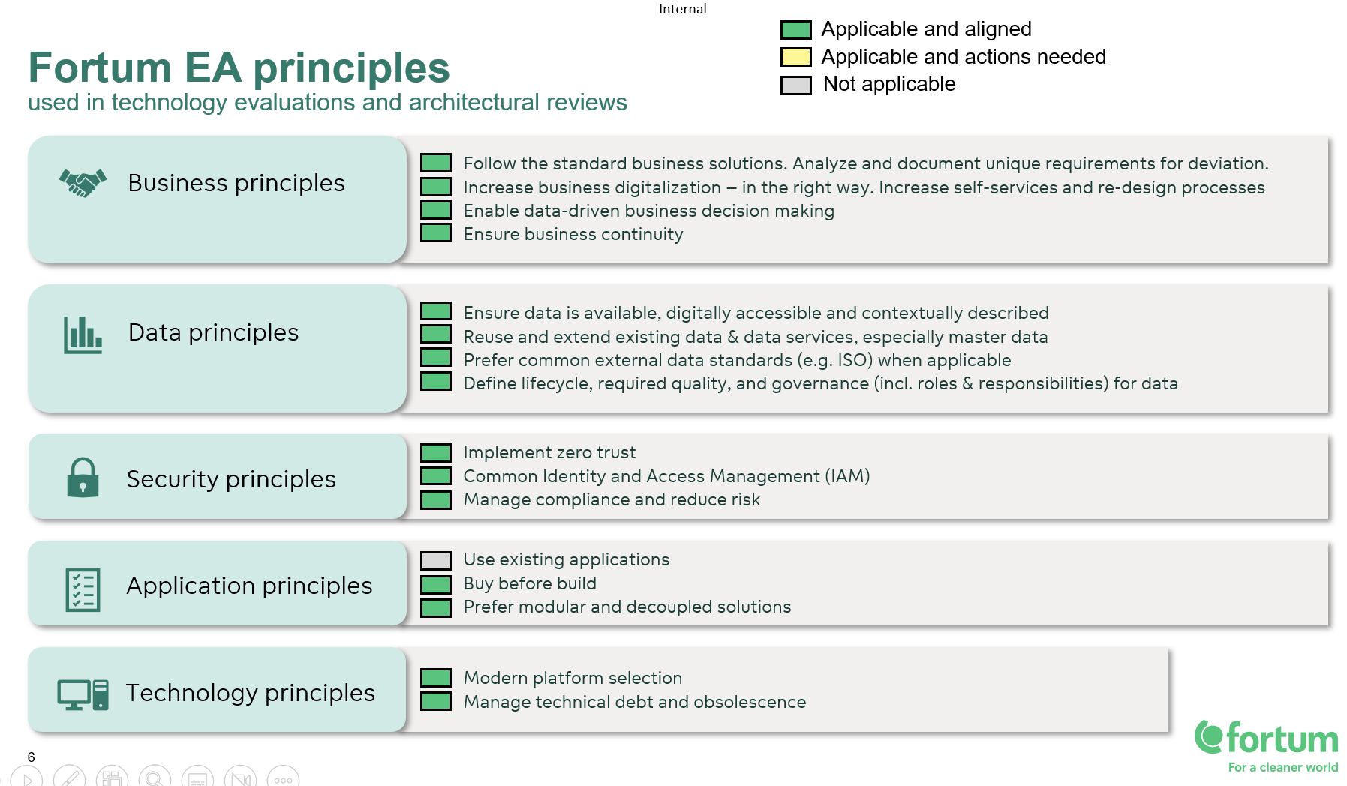

## Potential Reusability

IBM has changed Maximo Architecture with Maximo application suite and now it runs on Red Hat OpenShift Container Platform. Hence there is limitation of what can be re-used from a technological component's perspective. However, Fortum has decided to continue with Oracle as DB for MAS Manage hence, existing Oracle Infrastructure can be re-used as much as possible.

## Architectural Decisions

## MAS9 upgrade

Initial scope of the project was to upgrade Maximo 7612 to MAS8.11, but IBM has recently released MAS9 version and after conducting the impact analysis MAS9 has been considered in the scope instead of MAS8.11.

Though there is not much change in the upgrade process, there is risk which is identified as there have been no trials conducted, and we might see unforeseen issues.

## Non-Prod OCP Cluster

The decision has been made to have both non prod environments (Dev and Stage) on same OpenShift Cluster. The rationale behind this is to save on infra cost and it is in line with the current Maximo 7612 infra landscape. Below points have been discussed while making the decision and there were no concerns raised about these.

* Any outage for OCP will cause outage to all instances hosted on the cluster.
* Any releases for OCP will be applicable for all MAS instances hosted on the cluster.

## Disaster Recovery

The ARO clusters will be provisioned in one region with high availability by utilizing all availability zones of one region. However, from DR perspective it is recommended to have the cluster created in secondary region in Active-Active or Active-Passive architecture.

The decision has been made to not to implement the DR Architecture spreading in two different regions, the rationale behind this decision is probability of region failure and cost associated with it. Also, we do not have the DR setup in current Maximo 76 solution.

# Business Architecture

Below pictures show the Fortum business capability and the applicability of Maximo is highlighted in the picture.

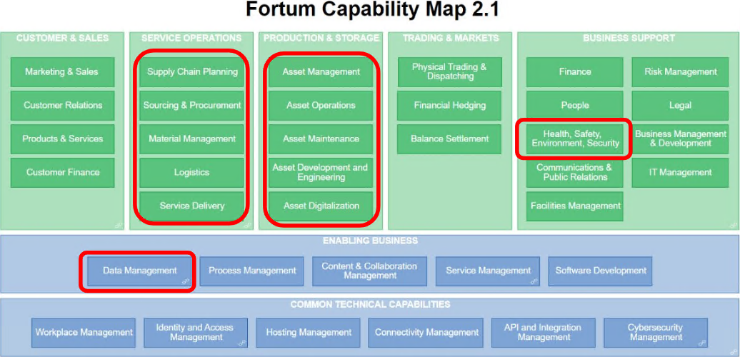

Below pictures shows the Fortum Business divisions and the applicability of Maximo is highlighted in the picture.

# Current Solution

Fortum’s current Maximo solution is on version 7.6.1.2, and it is hosted on Azure Cloud. It utilizes the Azure cloud as IaaS. Maximo is integrated with several system and it is utilizing Corporate BUS as middleware. Maximo is configured for Single Sign-On, and it authenticates against Azure AD.

It is configured for high availability utilizing 3 different servers with 26 UI, 6 MEA, 4 Reports, 2 CRON and 10 Mobile JVMs and the load is managed by F5 load balancer. Database is in RAC cluster on OCI having 2 different nodes.

Below picture shows the high-level Architecture of Maximo 7612.

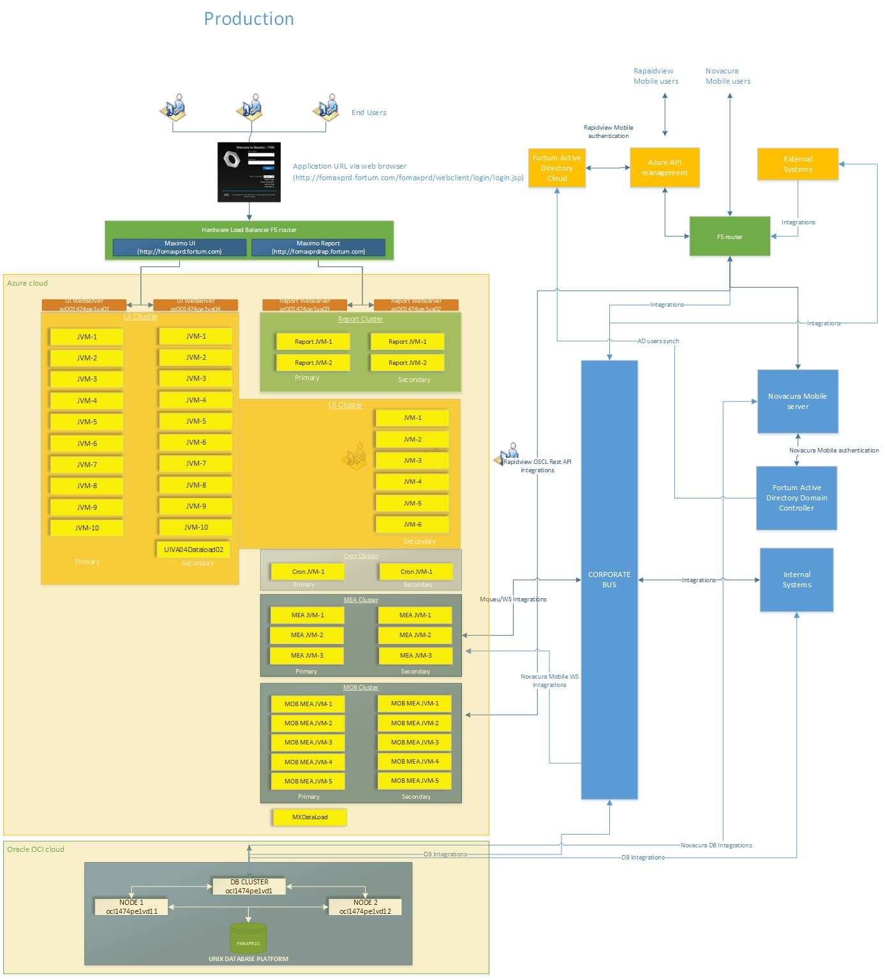

Below picture shows the high-level view of Maximo integrations.

# Target Solution

## Solution Overview

In the new world, Fortum Maximo application Suite will be hosted on Azure cloud utilizing Azure RedHat OpenShift (ARO) platform. This will be a shift from IaaS to PaaS model for underlying infra and technology. However, Maximo DB will continue to remain on Oracle Cloud Infrastructure (OCI) levering the existing setup.

Fortum already uses the Azure Cloud infrastructure for various applications and Azure Services for various organizational needs. MAS9 will be hosted in the existing Azure landing zone of Fortum.

Below picture explains the conceptual overview depicting the difference between AS-IS and TO-BE solution.

[Microsoft Azure Red Hat OpenShift](https://azure.microsoft.com/en-us/services/openshift/) is a fully managed service of [Red Hat OpenShift](https://developers.redhat.com/openshift) on Azure, jointly engineered, managed, and supported by Microsoft and Red Hat. Azure Red Hat OpenShift takes care of cluster and resource management, freeing developers to focus on developing new services (see below figure). The service offers a universally available control plane with fully managed master and application nodes—no virtual machines to operate and no patching required. Azure Red Hat OpenShift is backed by the expertise of site reliability engineers throughout the world.

**DB Migration from Oracle to IBM DB2 –**

This is not a part of the scope of this project, but the intend is to move from Oracle to IBM DB2 as database for Maximo after the upgrade. This is mainly to align with product roadmap and leverage the well-integrated architecture of DB2 with other MAS applications.

There are the hosting options which can be considered for DB2 –

1. Installing DB2 within OpenShift Cluster
2. Installing DB2 outside OpenShift Cluster

* Installed on Azure VMs as IaaS
* DB2 PaaS service on Azure

The detailed analysis needs to be done for each option to carefully select the DB2 hosting option compared against factors like Fortum cloud strategy, Cost, Project and Operational Complexity etc and the option which best fits the Fortum requirements needs to be selected.

## Technology Overview & Architecture

This section provides an overview of the Maximo Application Suite offerings and product capabilities to aid general understanding. It does not define the scope but is intended to help Fortum understand the features and plan the roadmap for Maximo accordingly.

IBM has introduced a substantial change to Maximo’s capabilities is the inclusion of multiple asset management products into a single suite of applications, and the introduction of a new common application ‘skin’ for user navigation throughout the suite.

The modules from the legacy Maximo system (e.g., Maximo 7.6.1.x) are in the “Manage” Application within the Maximo Application Suite. Industry and Add-on Solution functionality also remain available within Manage. Other modules in the Suite, such as Health and Predict (which were standalone products in the past) are now part of the Maximo Application Suite.

Maximo Manage reduces downtime and costs, while Maximo Monitor improves asset availability through advanced AI-powered remote asset monitoring. Maximo Health utilizes IoT data to manage asset health, and Maximo Visual Inspection allows for real-time identification of issues. Maximo Predict leverages condition-based action to predict future failures, and Maximo Mobile provides field technicians with all the necessary asset information. With its streamlined and user-friendly interface, the Maximo Application Suite enables organizations to achieve operational visibility, faster ROI, and increased productivity.

Offering these products in a single suite streamlines installation and administration, while enhancing the user experience with shared data, workflows, and a common user interface. In this way, Maximo Application Suite also enables easier access to a full set of asset lifecycle applications, with the flexibility to start at any point in the asset lifecycle and expand into other areas. The Maximo Application Suite can also be an accelerator to the digital transformation of traditional asset maintenance into Artificial Intelligence (AI) driven maintenance.

[**IBM Maximo Assist**](https://www.ibm.com/docs/en/SSRHPA_cd/appsuite/overview/c_assist.html)  
IBM Maximo Assist is an application in Maximo Application Suite. By using Maximo Assist, you can leverage AI-powered guidance and a knowledge base of equipment maintenance data to reduce the time that is required to diagnose and repair equipment problems, improve first-time fix rates, improve diagnosis accuracy, and drive higher levels of technician productivity. Using an intuitive mobile interface, you can diagnose equipment problems, find recommended solutions, and collaborate with experts to resolve problems.

[**IBM Maximo Health**](https://www.ibm.com/docs/en/SSRHPA_cd/appsuite/overview/c_health.html)IBM Maximo Health is an application in Maximo Application Suite. By using Maximo Health, you can improve your asset’s reliability by understanding asset health and acting. You can review your assets’ performance and condition indicators, such as the last failure date and the maintenance-to-replacement ratio (MRR) and take action by creating work orders and service requests. You can use work queues to improve the quality of your asset’s details and related data. You can also configure scoring for assets’ health, criticality, and risk.

[**IBM Maximo Manage**](https://www.ibm.com/docs/en/SSRHPA_cd/appsuite/overview/c_manage.html)  
IBM Maximo Manage is an application in Maximo Application Suite. By using Maximo Manage, you can get a comprehensive view of all of your asset types, their conditions and locations, and the work processes that support them, to support optimal planning, control, audit, and compliance capability.

[**IBM Maximo Monitor**](https://www.ibm.com/docs/en/SSRHPA_cd/appsuite/overview/c_monitor.html)IBM Maximo Monitor is an application in Maximo Application Suite. By using Maximo Monitor, you can visualize current and historical trend data for devices and assets in customizable dashboards.

[**IBM Maximo Predict**](https://www.ibm.com/docs/en/SSRHPA_cd/appsuite/overview/c_predict.html)IBM Maximo Predict is an application in Maximo Application Suite. By using Maximo Predict, you can leverage your historical and near real-time asset performance data, maintenance records, inspection reports, and environmental data to correlate performance factors that predict asset degradation or failure. Maximo Predict also uses artificial intelligence to optimize predictive model accuracy.

[**IBM Maximo Visual Inspection**](https://www.ibm.com/docs/en/SSRHPA_cd/appsuite/overview/c_visual_inspection.html)  
IBM Maximo Visual Inspection is a machine-learning application for video and image analysis in Maximo Application Suite. By using Maximo Visual Inspection, you can use built-in deep learning models to analyze images and video streams for classification and object detection

**IBM Maximo Safety**

Collect and analyze data from sensors, provide contextual data, and derive meaningful analytics.

**IBM Maximo Mobile**

IBM Mobility solution for Maximo, Fortum has already implemented the Maximo Mobile with Maximo 7612 and using Technician application which is customized as per Fortum requirements. As part of this project the same solution will be migrated to MAS9 version and will be remediated if needed to work with MAS9 version.

Apart from the Infrastructure, below are the key Technical Pre-Requisite for deploying and activating other MAS Applications. This does not cover the dependencies which will be installed with Maximo Manage by default like License Service, OpenShift Cluster, Manage DB etc.

|  |  |  |  |
| --- | --- | --- | --- |
| **Sr No** | **Applications** | **Purpose** | **Technical Dependencies (Pre-Requisite)** |
| 1 | **Monitor** | Enable real-time monitoring and anomaly detection for assets using IoT and operational data. By using Maximo Monitor, business users can visualize current and historical trend data for their devices and assets in customizable dashboards. | **- The IoT tool (Optional in MAS9):** The IoT tool can be used as the IoT device message broker for secure device registration, near real-time analytics, and more. In Maximo Monitor 9.0, you can create and manage gateways without using the IoT tool. You can still use the IoT tool to view recent events from devices. **- IBM Db2 Warehouse:** Db2 Warehouse is the Maximo Monitor data lake. Db2 Warehouse is a fully integrated data and API platform for storage and analytics of your IoT data. Db2 Warehouse can run in or external to the Maximo Application Suite Red Hat OpenShift cluster.  **- Cloud Pak for Data:** Needed for DB2 warehouse **- Apache Kafka -** Kafka supports internal communication between services in Maximo Application Suite. **- Edge Data Collector container image (optional)** - In Maximo Monitor 9.0, Edge Data Collector directly accessible from within Maximo Monitor as the device library. To use the device library, you must deploy the Edge Data Collector container image to related gateways or edge devices. **- Maximo Manage** - When you integrate with Maximo Manage, the Asset Data Dictionary is used to add data about organizations, sites, assets, and locations from Maximo Monitor to Maximo Manage |
| 2 | **Health** | By using Maximo Health, you can consolidate operation, asset, location, and maintenance data to gain insight into asset and location performance and to optimize preventive maintenance and, for assets, complete replacement planning. You can increase trust in your data by reviewing assets that have potential data quality issues, and you can configure asset and location scores to drive efficiency, optimize cost, and reduce risk. | **- MAS Manage -** You can either install the Maximo Health stand-alone application or the Maximo Health extension for Maximo Manage. It will use Maximo Manage DB if installed with Manage **- MAS Monitor (Optional)** - Data from sensors (such as temperature, vibration, and pressure) can be used to dynamically update the health score of assets. |
| 3 | **Predict** | Maximo Predict uses historical and near real-time asset performance data, maintenance records, inspection reports, and environmental data to correlate performance factors that predict asset degradation or failure. Maximo Predict uses artificial intelligence to optimize predictive model accuracy. | **- IBM Watson Studio & Machine Learning:** To collaboratively work on data to solve your business problems. You can choose the tools that you need to analyze and visualize data, to cleanse and modify data, to obtain streaming data, or to create and train machine learning models. **- Watson OpenScale** is an enterprise-grade environment for AI applications that provides your enterprise visibility into how your AI is built, is used, and delivers return on investment. - **Spark (Optional) -** You can optionally use Analytics Engine powered by Apache Spark to extend your Jupiter notebooks capabilities while dealing with large data sets in Maximo® Predict application. **- Maximo Monitor -** To improve the predictive model's ability to forecast asset failures based on real-time data. **- Maximo Health -** To make asset health scores and condition monitoring data available in Maximo Predict  **- Maximo Manage -** historical asset data, maintenance records, work orders, and failure data |
| 4 | **Assist** | IBM® Maximo® Assist provides technicians with AI-powered guidance through a knowledge base of equipment maintenance data and gives them remote access to experts for assistance. Using an intuitive mobile interface, technicians can diagnose equipment problems, find recommended solutions, and collaborate with experts to resolve problems. | - **S3-Compatible object storage -  - Watson Discovery -** Not a dependency for MAS9 **- Mobile Devices:** Compatible with smartphones, tablets, or laptops for field technicians. - **Augmented Reality (AR) toolkit**: AR tools may be used in combination for more complex technical assistance in some deployments. |
| 5 | **Safety** | IBM Maximo Safety enables companies to establish safer working environments by providing safety insights for proactive protection with personalized risk assessment and near real-time protection. These insights and protection can minimize workplace hazards. | **- IBM Db2 Warehouse database: - IoT tool:** The IoT tool provides device connectivity, data filtering and mapping, and device management tools and is required by the IBM Maximo Safety application. **- Maximo Manage:** Links safety incidents, permits, and work orders with assets and personnel. |
| 6 | **Visual Inspection** | IBM Maximo Visual Inspection is a machine-learning application for video and image analysis. IBM Maximo Visual Inspection offers built-in deep learning models that learn to analyze images and video streams for classification and object detection. | - **GPU worker node to a Red Hat OpenShift cluster** **- Edge Devices:** Requires cameras, drones, or other image-capturing devices. |

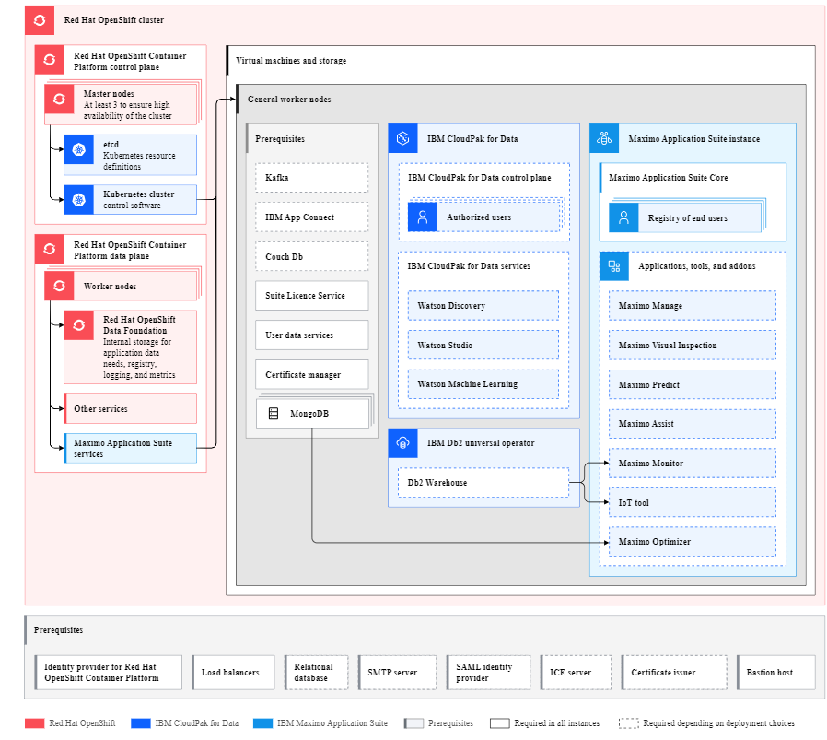

## Logical Architecture

Below picture shows the logical architecture of Fortum’s Maximo Solution.



* **Azure Cloud -** Fortum MAS solution will be hosted on Fortum Azure cloud in West Europe Region.
* **Azure ARO –** Azure RedHat OpenShift (ARO) service will be leveraged in West Europe region. Azure Red Hat OpenShift provides highly available, fully managed OpenShift clusters on demand, monitored and operated jointly by Microsoft and Red Hat.
* **Maximo Application Suite -** Maximo Application Suite (MAS) is a set of applications providing Enterprise Asset Management (EAM), Asset Performance Management (APM) and some additional applications which are based on AI. MAS is recognized as a leading Asset Life-Cycle Management (ALM) Application. For the current solution only Manage and Mobile is considered.
* **Mongo DB -** MongoDB is used as the data dictionary for Maximo Application Suite and its component applications. It is also used as the default user registry. Community version of MongoDB will be used which comes with MAS installation binaries.
* **DRO -** The IBM Data Reporter Operator accepts events and transforms them into reports that are submitted to the Data Service of the IBM Metrics Operator to collect and process metrics for licensing compliance. The Metric operator captures and sends these reports to IBM. Starting in IBM Maximo Application Suite 8.10.10, the User Data Services (UDS) is deprecated and replaced with IBM Data Reporter Operator (DRO), resulting in a lower operational footprint.
* **SLS -** IBM Suite License Service provides features for managing virtualized environments and measuring license utilization. Suite License Service discovers the software that is installed in your infrastructure, helps you to analyze the consumption data, and generates audit reports. Each report provides you with different information about your infrastructure, for example the computer groups, software installations, and the content of your software catalog.
* **Certificate Manager -** IBM Certificate Manager service helps you manage and deploy SSL/TLS certificates for your apps and services. Certificate Manager provides you with a security-rich repository for your certificates and their associated private keys, and helps prevent outages by sending you notifications when your certificates are about to expire.

Maximo Application Suite uses IBM Certificate Manager service to control certificate management. This service ensures that certificates are valid and up to date, and attempts to renew certificates at a configured time before expiry. For Fortum Lets Encrypt certificate will be configured using certificate manager.

* **Manage** - The first part of the Maximo Application Suite is called Maximo Manage; it is the traditional Maximo with enhanced features and it is what Fortum is using currently.
* **Maximo Mobile –** Maximo Mobile is mobility solution provided by IBM as part of Maximo Application Suite and it is integrated in Maximo Manage. Maximo Mobile has several applications and features availableout of the box. Fortum has already implemented the Maximo Mobile with Maximo 7612 and using Technician application which is customized as per Fortum requirements. As part of this project the same solution will be migrated to MAS9 version and will be remediated if needed to work with MAS9 version.
* **Oracel DB –** Maximo Manage supports IBM Db2, IBM Db2 Warehouse, Microsoft SQL Server, and Oracle Database. Fortum solution will use Oracle DB as database for Maximo Manage.
* **Prometheus -** Maximo Application Suite applications provide application level metrics and dashboards for monitoring various aspects for application health and performance. Maximo Application Suite uses the Prometheus monitoring stack within OCP for storing application level metrics. Maximo Application Suite also uses Grafana for rendering application level metrics in integrated dashboards.
* **Grafana -** OpenShift Container Platform is preconfigured with a Grafana instance for visualizing Prometheus metrics from compute nodes in the cluster. This Grafana instance is reserved for OCP cluster metrics, such as compute node CPU, memory, disk, and I/O metrics. Maximo Application Suite applications cannot use the base Grafana instance. You can install another Grafana instance to host dashboards for Maximo Application Suite applications.
* **Azure AD -** Azure Active Directory (Azure AD), now known as Microsoft Entra ID, is an identity and access management solution from Microsoft that helps organizations secure and manage identities for hybrid and multicloud environments. SAML Authentication for MAS application will be configured against Azure AD.
* **On-Prem Active Directory –** On-PremActive directory (AD) will be synchronized with Azure AD. MAS application will communicate with On-Prem AD for user provisioining from AD to MAS. Option to sync user registry from Azure Entra ID groups has been explored but MAS is not a standard Entra Gallary App hence implementing the solution for user sync from Entra ID to MAS will be customization hence, existing LDAP sync method will be used against on-prem AD.
* **SMTP –** On Prem SMTP server will be used to configure email feature in MAS Application. Option to configure Microsoft 365 for email with Maximo has been explored but because of complexity involved with configuring it with Maximo, it is proposed to continue with existing solution which is OnPrem SMTP relay.
* **Corporate BUS –** Corporate BUS is used as middleware for all Maximo integrations with different Fortum external systems.
* **Azure Files -** Azure Files offers fully managed file shares in the cloud that are accessible via the industry standard Server Message Block (SMB) protocol, Network File System (NFS) protocol, and Azure Files REST API. Azure files will be used for Maximo Attachments and for custom archive in Fortum solution.
* **Azure Key Vault –** Azure Key Vault service will be used to store the application and openshift credentials.
* **Maximo Users –** We expect Maximo desktop and Mobile users to connect Maximo Manage over internet as well as from Fortum network.

## Network Architecture

Below is the high-level architecture diagram of Solution on azure cloud explaining the network components involved.

## Application Architecture

Below diagram shows the to-be architecture of Maximo Application on Azure ARO. It will be connected to several external systems to exchange the data as per existing integration solution in Maximo 76. All the external systems will be connected through CBUS middleware. Apart from that Maximo will have integration with Azure AD and On-Prem AD for SAML and user provisioning respectively.



# Information Flow

## MAS Manage Modules

No changes to information architecture at an object and table level are envisaged, apart from de-customization changes which will be implemented as part of this project to move away from java customization. This remediation will cover necessary changes to tables, attributes, and configuration changes made for each of the functionality where java customization was done in previous versions of Maximo.

The figures below show the general flow of information between applications:

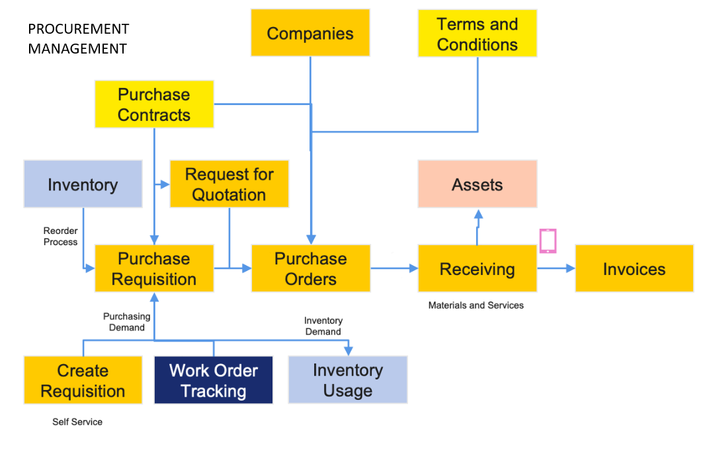

## Integrations

Below is the list of active integrations of Maximo 76 which is an extract of ARS. Same integration will be retrofitted in MAS9.

|  |  |  |
| --- | --- | --- |
| **Integration ID** | **Integration** | **Status** |
| [INT001840](https://arsclient.fortum.com/arsys/servlet/ViewFormServlet?form=Fortum_A_Integration&server=ars&eid=INT001840) | ARS-CBUS-MAXIMO 7 (User Financial Authorities by Company) | Active |
| [INT005518](https://arsclient.fortum.com/arsys/servlet/ViewFormServlet?form=Fortum_A_Integration&server=ars&eid=INT005518) | Basware P2P – CBUS – Maximo (Invoice payment info to Maximo) | Active |
| [INT005517](https://arsclient.fortum.com/arsys/servlet/ViewFormServlet?form=Fortum_A_Integration&server=ars&eid=INT005517) | Basware P2P – CBUS – Maximo (Matched against Maximo purchase orders) | Active |
| [INT005516](https://arsclient.fortum.com/arsys/servlet/ViewFormServlet?form=Fortum_A_Integration&server=ars&eid=INT005516) | Basware P2P – CBUS – Maximo (Matched Labor Invoice) | Active |
| [INT005530](https://arsclient.fortum.com/arsys/servlet/ViewFormServlet?form=Fortum_A_Integration&server=ars&eid=INT005530) | Basware P2P – CBUS – Maximo (Maximo purchase order retrieval requests from Basware P2P) | Active |
| [INT001692](https://arsclient.fortum.com/arsys/servlet/ViewFormServlet?form=Fortum_A_Integration&server=ars&eid=INT001692) | DRIFTDATA-CBUS-FORTUM MAXIMO 7 (Work orders) | Active |
| [INT001646](https://arsclient.fortum.com/arsys/servlet/ViewFormServlet?form=Fortum_A_Integration&server=ars&eid=INT001646) | FINA-CBUS-FORTUM MAXIMO 7 (Companies from Fina to Maximo7) | Active |
| [INT001642](https://arsclient.fortum.com/arsys/servlet/ViewFormServlet?form=Fortum_A_Integration&server=ars&eid=INT001642) | FINA-CBUS-FORTUM MAXIMO 7 (Currency exchange rates from FINA to Maximo 7) | Active |
| [INT001649](https://arsclient.fortum.com/arsys/servlet/ViewFormServlet?form=Fortum_A_Integration&server=ars&eid=INT001649) | FINA-CBUS-FORTUM MAXIMO 7 (glAccountStrings from Fina to Maximo 7) | Active |
| [INT001648](https://arsclient.fortum.com/arsys/servlet/ViewFormServlet?form=Fortum_A_Integration&server=ars&eid=INT001648) | FINA-CBUS-FORTUM MAXIMO 7 (glSegments from Fina to Maximo 7) | Active |
| [INT002175](https://arsclient.fortum.com/arsys/servlet/ViewFormServlet?form=Fortum_A_Integration&server=ars&eid=INT002175) | FINA-CBUS-FORTUM MAXIMO 7 (Work Order Numbers to Maximo7) | Active |
| [INT003258](https://arsclient.fortum.com/arsys/servlet/ViewFormServlet?form=Fortum_A_Integration&server=ars&eid=INT003258) | Flow-CBUS-Poland Contactis (eBok/Crm (WorkdOrder, WorkLog)) | Active |
| [INT008423](https://arsclient.fortum.com/arsys/servlet/ViewFormServlet?form=Fortum_A_Integration&server=ars&eid=INT008423) | Fomax-Cbus-KiskoCRM (Work Order) | Active |
| [INT001555](https://arsclient.fortum.com/arsys/servlet/ViewFormServlet?form=Fortum_A_Integration&server=ars&eid=INT001555) | Fortum Maximo - Qlik Sense | Active |
| [INT013400](https://arsclient.fortum.com/arsys/servlet/ViewFormServlet?form=Fortum_A_Integration&server=ars&eid=INT013400) | Fortum Maximo 7 - ADP | Active |
| [INT003826](https://arsclient.fortum.com/arsys/servlet/ViewFormServlet?form=Fortum_A_Integration&server=ars&eid=INT003826) | Fortum Maximo 7 - CBUS - Asset Data Platform | Active |
| [INT004451](https://arsclient.fortum.com/arsys/servlet/ViewFormServlet?form=Fortum_A_Integration&server=ars&eid=INT004451) | Fortum Maximo 7 - FIDO DW | Active |
| [INT010213](https://arsclient.fortum.com/arsys/servlet/ViewFormServlet?form=Fortum_A_Integration&server=ars&eid=INT010213) | Fortum Maximo 7-CBUS-CONTACTIS Poland (WorkOrder Status and Log) | Active |
| [INT001644](https://arsclient.fortum.com/arsys/servlet/ViewFormServlet?form=Fortum_A_Integration&server=ars&eid=INT001644) | FORTUM MAXIMO 7-CBUS-FINA (Journalentries Material usage, Invoice variance, Inventory cost, and adjustment transactions) | Active |
| [INT003613](https://arsclient.fortum.com/arsys/servlet/ViewFormServlet?form=Fortum_A_Integration&server=ars&eid=INT003613) | FORTUM MAXIMO 7-CBUS-FLOW (Assets, Locations) | Active |
| [INT003175](https://arsclient.fortum.com/arsys/servlet/ViewFormServlet?form=Fortum_A_Integration&server=ars&eid=INT003175) | FORTUM MAXIMO 7-CBUS-FLOW (Journalentries Material usage, Invoice variance, Inventory cost) | Active |
| [INT002424](https://arsclient.fortum.com/arsys/servlet/ViewFormServlet?form=Fortum_A_Integration&server=ars&eid=INT002424) | Fortum Maximo 7-CBUS-Intellidam | Active |
| [INT001658](https://arsclient.fortum.com/arsys/servlet/ViewFormServlet?form=Fortum_A_Integration&server=ars&eid=INT001658) | FORTUM MAXIMO 7-CBUS-PAWE (Pawe-Labor hrs update inbound/outbound) | Active |
| [INT001657](https://arsclient.fortum.com/arsys/servlet/ViewFormServlet?form=Fortum_A_Integration&server=ars&eid=INT001657) | FORTUM MAXIMO 7-CBUS-PAWE (Pawe-Labor update) | Active |
| [INT002633](https://arsclient.fortum.com/arsys/servlet/ViewFormServlet?form=Fortum_A_Integration&server=ars&eid=INT002633) | FORTUM MAXIMO 7-CBUS-PAWE (Work Order Feedback) | Active |
| [INT000466](https://arsclient.fortum.com/arsys/servlet/ViewFormServlet?form=Fortum_A_Integration&server=ars&eid=INT000466) | FORTUM MAXIMO 7-CBUS-PAWE (Work orders ) | Active |
| [INT002034](https://arsclient.fortum.com/arsys/servlet/ViewFormServlet?form=Fortum_A_Integration&server=ars&eid=INT002034) | FORTUM MAXIMO 7-CBUS-PAWE (Work Orders) | Active |
| [INT003794](https://arsclient.fortum.com/arsys/servlet/ViewFormServlet?form=Fortum_A_Integration&server=ars&eid=INT003794) | FORTUM MAXIMO 7-CBUS-Pawe, HeadPower (Work Orders) | Active |
| [INT002437](https://arsclient.fortum.com/arsys/servlet/ViewFormServlet?form=Fortum_A_Integration&server=ars&eid=INT002437) | Fortum Maximo7-CBUS-ARS (Technical groups) | Active |
| [INT003107](https://arsclient.fortum.com/arsys/servlet/ViewFormServlet?form=Fortum_A_Integration&server=ars&eid=INT003107) | Fortum Maximo7-CBUS-FILE SERVICES(JPK) | Active |
| [INT001985](https://arsclient.fortum.com/arsys/servlet/ViewFormServlet?form=Fortum_A_Integration&server=ars&eid=INT001985) | FORTUM MAXIMO7-CBUS-INTFACE FLOW (Basic Work Order) | Active |
| [INT001986](https://arsclient.fortum.com/arsys/servlet/ViewFormServlet?form=Fortum_A_Integration&server=ars&eid=INT001986) | FORTUM MAXIMO7-CBUS-INTFACE FLOW (Route Work Order) | Active |
| [INT002379](https://arsclient.fortum.com/arsys/servlet/ViewFormServlet?form=Fortum_A_Integration&server=ars&eid=INT002379) | Fortum Maximo7-CBUS-Simpson (NOMa integration) | Active |
| [INT001956](https://arsclient.fortum.com/arsys/servlet/ViewFormServlet?form=Fortum_A_Integration&server=ars&eid=INT001956) | HERMES-CBUS-FORTUM MAXIMO7 (Personal Data) | Active |
| [INT004657](https://arsclient.fortum.com/arsys/servlet/ViewFormServlet?form=Fortum_A_Integration&server=ars&eid=INT004657) | INTFACE Ahlsell-CBUS-Maximo 7 (Fortum Maximo Ahlsell punchout integration) | Active |
| [INT001987](https://arsclient.fortum.com/arsys/servlet/ViewFormServlet?form=Fortum_A_Integration&server=ars&eid=INT001987) | INTFACE FLOW-CBUS-FORTUM MAXIMO7 (Comment) | Active |
| [INT001989](https://arsclient.fortum.com/arsys/servlet/ViewFormServlet?form=Fortum_A_Integration&server=ars&eid=INT001989) | INTFACE FLOW-CBUS-FORTUM MAXIMO7 (Material Cost and Service Cost) | Active |
| [INT001988](https://arsclient.fortum.com/arsys/servlet/ViewFormServlet?form=Fortum_A_Integration&server=ars&eid=INT001988) | INTFACE FLOW-CBUS-FORTUM MAXIMO7 (Reported Hours) | Active |
| [INT001990](https://arsclient.fortum.com/arsys/servlet/ViewFormServlet?form=Fortum_A_Integration&server=ars&eid=INT001990) | INTFACE FLOW-CBUS-FORTUM MAXIMO7 (Work Order) | Active |
| [INT002405](https://arsclient.fortum.com/arsys/servlet/ViewFormServlet?form=Fortum_A_Integration&server=ars&eid=INT002405) | Kaukolämpö Plus - CBUS - Fortum Maximo 7 (Purchase Order) | Active |
| [INT002406](https://arsclient.fortum.com/arsys/servlet/ViewFormServlet?form=Fortum_A_Integration&server=ars&eid=INT002406) | Kaukolämpö Plus - CBUS - Fortum Maximo 7 (Receive Purchase Order) | Active |
| [INT002404](https://arsclient.fortum.com/arsys/servlet/ViewFormServlet?form=Fortum_A_Integration&server=ars&eid=INT002404) | Kaukolämpö Plus - CBUS - Fortum Maximo 7 (Work Order) | Active |
| [INT008101](https://arsclient.fortum.com/arsys/servlet/ViewFormServlet?form=Fortum_A_Integration&server=ars&eid=INT008101) | KISKO CRM-CBus-Fortum Maximo (Work Orders) | Active |
| [INT007801](https://arsclient.fortum.com/arsys/servlet/ViewFormServlet?form=Fortum_A_Integration&server=ars&eid=INT007801) | Lotsen - CBUS - Maximo (Work orders) | Active |
| [INT005523](https://arsclient.fortum.com/arsys/servlet/ViewFormServlet?form=Fortum_A_Integration&server=ars&eid=INT005523) | Maximo – CBUS – Basware P2P (Work Order and Work Order History data to P2P) | Active |
| [INT007802](https://arsclient.fortum.com/arsys/servlet/ViewFormServlet?form=Fortum_A_Integration&server=ars&eid=INT007802) | Maximo - CBUS - Lotsen (Work order updates) | Active |
| [INT010309](https://arsclient.fortum.com/arsys/servlet/ViewFormServlet?form=Fortum_A_Integration&server=ars&eid=INT010309) | Maximo - cbus - M-files | Active |
| [INT003633](https://arsclient.fortum.com/arsys/servlet/ViewFormServlet?form=Fortum_A_Integration&server=ars&eid=INT003633) | Maximo (Espoo) - CBUS - SMSGateway (Maximo Disturbance reporting) | Active |
| [INT005524](https://arsclient.fortum.com/arsys/servlet/ViewFormServlet?form=Fortum_A_Integration&server=ars&eid=INT005524) | Maximo, Lomax – CBUS – Basware P2P (Converts Labor Invoices to P2P matching order | Active |
| [INT003943](https://arsclient.fortum.com/arsys/servlet/ViewFormServlet?form=Fortum_A_Integration&server=ars&eid=INT003943) | Maximo7-CBUS-FortumSMS | Active |
| [INT002035](https://arsclient.fortum.com/arsys/servlet/ViewFormServlet?form=Fortum_A_Integration&server=ars&eid=INT002035) | PAWE-CBUS-FORTUM MAXIMO 7 (Labor Union Code) | Active |
| [INT001693](https://arsclient.fortum.com/arsys/servlet/ViewFormServlet?form=Fortum_A_Integration&server=ars&eid=INT001693) | PAWE-CBUS-FORTUM MAXIMO 7 (Pawe-Reported Hours) | Active |
| [INT002037](https://arsclient.fortum.com/arsys/servlet/ViewFormServlet?form=Fortum_A_Integration&server=ars&eid=INT002037) | PAWE-CBUS-FORTUM MAXIMO 7 (Work Order Feedback) | Active |
| [INT001802](https://arsclient.fortum.com/arsys/servlet/ViewFormServlet?form=Fortum_A_Integration&server=ars&eid=INT001802) | PAWE-CBUS-FORTUM MAXIMO 7 (Workorder Hour Status) | Active |
| [INT003257](https://arsclient.fortum.com/arsys/servlet/ViewFormServlet?form=Fortum_A_Integration&server=ars&eid=INT003257) | Poland Contactis - CBUS - Fortum Maximo7/Flow | Active |
| [INT004573](https://arsclient.fortum.com/arsys/servlet/ViewFormServlet?form=Fortum_A_Integration&server=ars&eid=INT004573) | Qlik Sense - Maximo | Active |
| [INT004250](https://arsclient.fortum.com/arsys/servlet/ViewFormServlet?form=Fortum_A_Integration&server=ars&eid=INT004250) | SOA-CBUS-Maximo API (RapidView Mobile Maximo) | Active |
| [INT009613](https://arsclient.fortum.com/arsys/servlet/ViewFormServlet?form=Fortum_A_Integration&server=ars&eid=INT009613) | SuccessFactors-CBUS-PAWE (HR-data) | Active |
| [INT001647](https://arsclient.fortum.com/arsys/servlet/ViewFormServlet?form=Fortum_A_Integration&server=ars&eid=INT001647) | Topi (multiple TOpi applications)-CBUS-Fortum Maximo 7 | Active |
| [INT008800](https://arsclient.fortum.com/arsys/servlet/ViewFormServlet?form=Fortum_A_Integration&server=ars&eid=INT008800) | Työlupa-Cbus-Maximo (Työlupa requests for Maximo Work Orders) | Active |
| [INT008401](https://arsclient.fortum.com/arsys/servlet/ViewFormServlet?form=Fortum_A_Integration&server=ars&eid=INT008401) | xHeat-CBus-Fortum Maximo (Metering Point Coordinates/Locations) | Active |

# Deployment Overview

## Deployment View

There are several options to provision Maximo Application Suite on Azure, but they are mainly classified in below categories. MAS for Fortum will be deployed on Azure with 3rd option from below table. Azure RedHat OpenShift (ARO) service will be utilized to host Fortum MAS instances.

|  |  |  |  |  |  |
| --- | --- | --- | --- | --- | --- |
| **Installation option** | **MAS installation** | **MAS installation customization** | **Platform creation** | **Platform control** | **Platform (OCP) management** |
| Option 1  (BYOL or Marketplace offering) | Scripted | Less customization | Scripted | Complete control | Customer managed |
| Option 2 (IaaS) | Manual by customer | More customization | Customer driven | Complete control | Customer managed |
| **Option 3 (PaaS)** | **Manual by customer** | **More customization** | **Scripted** | **Less control** | **Red Hat SRE managed** |

Below diagram shows the typical installation of Maximo on Azure ARO.

Once Azure ARO is provisioned, MAS installation will be done using the MAS CLIs which uses OCP devops pipelines for the installation of Maximo.

There are couple of options for installing MAS application on OCP cluster, one using Ansible scripts provided by IBM and other one is MAS CLI which use OCP pipelines.

MAS CLI option will be used to install MAS on OCP and MAS Manage application will be deployed and activated through MAS Core application Console. This approach is explained in below IBM article.

https://ibm-mas.github.io/cli/

## Environment View

Fortum will have 3 MAS environments which will be created as part of MAS upgrade project – Dev, Stage and Prod. Apart from this one MAS vanilla instance will also be provisioned without Fortum data and solution.

Below table explains the purpose of each environment.

|  |  |  |  |  |
| --- | --- | --- | --- | --- |
| **Environment Name** | **VANILLA** | **DEV** | **STAGE** | **PROD** |
| **Project Purpose** | * OOB Solution Reference * OOB Bug identification * Testing MAS releases/Upgrades | * Upgrade & Development activities * Integration development * Report Development  De-Customization * Issue fixes * Unit Testing | * Integration Testing * SIT * UAT * Training | * Performance Testing * Pen Testing * Cutover & Go-Live |
| **BAU Purpose** | * OOB Solution Reference * OOB Bug identification * Testing MAS releases/Upgrades | * Development Activities * Unit Testing | * Integration Testing * SIT * UAT * Training | * Live System |

Below picture shows the logical separation of MAS environments.



**Red Hat OpenShift Cluster**

**Vanilla**



**Maximo Application Suite – Vanilla**

vanilla.fomax.fortum.com

**Workspace - Vanilla**

**MAS Core**

**MAS Manage**

**MAS Mobile**

**Maximo Application Suite – Vanilla**

Prerequisite Software for Prod

License Server

Mongo DB

Prometheus

Elasticsearch, Fluentd and Kibana

**OIC**

**Cloud**

**Maximo Vanilla DB**

* Each cluster will run multiple Maximo Application Suite instances for non-prod.
* Vanilla Cluster will be on separate cluster with IBM Demo data.
* Each instance will run its own set of pods and runtime code.
* All instances within the cluster shares a license pool.
* Each instance will have its own workloads.
* Worker nodes capacity management is done per instance.
* Prerequisites stack is defined at the instance level.
* Independent storage clusters per instance.
* Any outage for OCP will cause outage to all instances hosted on the cluster.
* Any releases for OCP will be applicable for all MAS instances hosted on the cluster.

Below are the URLs for each of the environment showing domains name utilization –

## Vanilla URLs

* admin.vanilla.fomax.fortum.com
* auth.vanilla.fomax.fortum.com
* [home.](http://home.fomax-dev.fortum.com/)vanilla.fomax.fortum.com
* vanilla.manage.vanilla.fomax.fortum.com

## DEV URLs

* admin.dev.fomax.fortum.com
* auth.dev.fomax.fortum.com
* home.dev.fomax.fortum.com
* dev.manage.dev.fomax.fortum.com

## Stage URLs

* admin.stage.fomax.fortum.com
* auth.stage.fomax.fortum.com
* [home.](http://home.fomax-dev.fortum.com/)stage.fomax.fortum.com
* stage.manage.stage.fomax.fortum.com

## Prod URLs

* admin.fomax.fortum.com
* auth.fomax.fortum.com
* [home.](http://home.fomax-dev.fortum.com/)fomax[.fortum.com](http://home.fomax-dev.fortum.com/)
* prod.manage.fomax.fortum.com

## Infra Specification

Below sections shows the Azure RedHat OpenShift (ARO) Cluster capacity for each of the cluster. 3 separate ARO clusters will be created as part of environment provisioning. The proposed capacity is based on analysis of Concurrent User, DB and Attachment storage growth in last 2-3 years.

The current concurrency of users on Maximo 76 has been analysed and below trend shows the data for last 2 years.

Below important points have been considered to derive the Infra capacity for Production environment –

* Reduced and stable concurrency of Maximo users for last 2 years except June 2024 onward
* Increase of ~30% user concurrency because of onboarding of maintenance personnel for Hydro area in Sweden and Finland, starting from 1st of June 2024
* Maximo Mobile rollout plan for other sites in near future which will see some growth of concurrent users but not significant as there won’t be onboarding of new users but encouraging Maximo users to use mobile apps.
* Fortum is selling Recycling and waste Business entities along with TSA which will see reduction in Maximo users.
  + This will include KUM, MCFI, NBG and RIA sites of Maximo.
  + This will see a reduction of ~400 active users out of ~1700 active users (roughly 25% of user base)
* Maximo 76 is originally designed to handle 800+ concurrent users and more than 125 integrations with 26 UI, 4 Report, 6 MEA, 2 CRON, 2 data load and 10 Mobile JVMs. But over the period Fortum has sold many business areas in Sweden, Stockholm (huge One), Norway, Oslo, Baltic countries and some areas in Finland. Hence MAS capacity will be defined as per future needs rather than replicating the current capacity.

Below capacity has been derived based on the assumption of user and integration load shown below.

|  |  |  |  |  |  |  |
| --- | --- | --- | --- | --- | --- | --- |
|  | **Remarks** | **Last 2 years** | **Forecast over next 3 years** | **Current Value** | **Expected value in next 3 years** | **Design Value** |
| **Maximo User Growth - Peak Concurrency** | Peak user concurrency decreased from 450 to 350 in last 2 years, no data available prior to Apr 2022. | -25% | 25% | 350 | 438 | **500** |
| **DB Storage Growth** | Current DB Size ~350GB, 20GB growth on average, 100 GB in the last 5 years | 12% | 20% | 350 | 420 | **500** |
| **Attachment Storage Growth** | Past growth calculated based on number of record growth in doclink table with consideration of average file size | 24% | 40% | 155 | 217 | **500** |

## Application Infra

## OCP Cluster Machine Types -

|  |  |  |  |
| --- | --- | --- | --- |
| **OpenShift Nodes** | | | |
| **Node Type** | **Role** | **Purpose** | **Remarks** |
| Master | Control plane of the cluster | - Manage the cluster state - Schedule workloads to worker nodes - Provide APIs for interaction with the cluster | For production, typically deployed as a set of 3 or more master nodes for redundancy |
| Worker | Data plane of the cluster | - Run application workloads (pods) - Execute tasks assigned by the master node | Worker nodes are scaled up or down based on workload requirements |
| Infra | Dedicated nodes for cluster services | - Host OpenShift-specific services and components, such as: 1 Router (Ingress/Load balancer for applications) 2 Registry (Internal container image registry) 3 Monitoring and logging components 4 Metrics storage - Offload these workloads from worker nodes | These are optional but recommended to use separate infrastructure nodes to enhance cluster performance and reliability |

**Cluster Infra Capacity**

|  |  |  |  |  |  |  |  |
| --- | --- | --- | --- | --- | --- | --- | --- |
| **Vanilla Cluster** | | | | | | | |
|  | **Quantity** | **Instance** | **vCPU(s)** | **RAM** | **File Storage** | **API server visibility** | **Ingress visibility** |
| Master | 3 | D8s v5 | 8 | 32 | 200 | N | N |
| Worker | 2 | D16s v5 | 16 | 64 | 200 |
| Infra | 3 | D4s v5 | 4 | 16 | 200 |
| **Total** | | | **68** | **272** | **1.6TB** |  |  |

|  |  |  |  |  |  |  |  |
| --- | --- | --- | --- | --- | --- | --- | --- |
| **Non-Prod Cluster (Dev & Stage)** | | | | | | | |
|  | **Quantity** | **Instance** | **vCPU(s)** | **RAM** | **File Storage** | **API server visibility** | **Ingress visibility** |
| Master | 3 | D8s v5 | 8 | 32 | 200 | N | N |
| Worker | 3 | D16s v5 | 16 | 64 | 200 |
| Infra | 3 | D4s v5 | 4 | 16 | 200 |
| **Total** | | | **84** | **336** | **1.8TB** |  |  |

|  |  |  |  |  |  |  |  |
| --- | --- | --- | --- | --- | --- | --- | --- |
| **Prod Cluster** | | | | | | | |
|  | **Quantity** | **Instance** | **vCPU(s)** | **RAM** |  | **API server visibility** | **Ingress visibility** |
| Master | 3 | D8s v5 | 8 | 32 | 1TB | N | N |
| Worker | 5 | D16s v5 | 16 | 64 | 1TB |
| Infra | 3 | D4s v5 | 4 | 16 | 128GB |
| **Total** | | | **116** | **464** | **8.4TB** |  |  |

## Database Infra

All MAS Databases will be hosted on existing OCI cloud infra and no additional infra will be provisioned.

* MAS Manage Vanilla and Dev DB will be provisioned on existing Dev DB server.
* MAS Manage DB will be provisioned on existing Stage DB Server
* MAS Manage DB will be provisioned on existing Prod DB Server.

This is with intention to save cost on additional infra and efforts for both provisioning of new servers for MAS and decommissioning of existing 7.6 DB servers.

**IMP Note** – ***While we have both Maximo 7.6 and MAS Manage DBs running on same DB servers, we need to upscale the capacity of these existing servers by double to cope with the additional load for new Dbs. This will be temporary arrangement and once Maximo DBs are decommissioned then servers will be re-configured with below specifications.***

The Oracle DB features like Advanced Compression and Advanced Security which are causing significant cost for databases will be evaluated to check if we can disable them if not required by Maximo Application and Fortum.

Below Tables shows the To-Be capacity of MAS DB servers (post decommissioning of Maximo 7.6 DBs).

|  |  |  |  |  |  |  |
| --- | --- | --- | --- | --- | --- | --- |
| **MAS VANILLA DB** | | | | | | |
| **Server** | **Existing?** | **OS** | **CPU** | **RAM** | **Storage** | **DB Version** |
| ocl1474de1vd02 | YES | Oracle Linux 8.11 | 4 | 30 GB | 500 GB | Database Release Update 19.24 |

|  |  |  |  |  |  |  |
| --- | --- | --- | --- | --- | --- | --- |
| **MAS DEV DB** | | | | | | |
| **Server** | **Existing?** | **OS** | **CPU** | **RAM** | **Storage** | **DB Version** |
| ocl1474de1vd02 | YES | Oracle Linux 8.11 | 4 | 30 GB | 1 TB | Database Release Update 19.24 |

|  |  |  |  |  |  |  |
| --- | --- | --- | --- | --- | --- | --- |
| **MAS STAGE DB** | | | | | | |
| **Server** | **Existing?** | **OS** | **CPU** | **RAM** | **Storage** | **DB Version** |
| ocl1474se1vd11 | YES | Oracle Linux 8.11 | 4 | 30 GB | 1 TB | Database Release Update 19.24 |

|  |  |  |  |  |  |  |
| --- | --- | --- | --- | --- | --- | --- |
| **MAS PROD DB** | | | | | | |
| **Server** | **Existing?** | **OS** | **CPU** | **RAM** | **Storage** | **DB Version** |
| ocl1474pe1vd12 | YES | Oracle Linux 8.11 | 8 | 62GB | 2.5TB | Database Release Update 19.24 |

# Cutover & Migration

Maximo Cutover will have below main steps –

1. DB backup from Prod and Restore on Project Environment
2. Maximo 7613 FP
3. MAS9 upgrade
4. Retrofit Integrations and Deploy Reports & Customization changes.

More granular steps are captured in the diagram below.

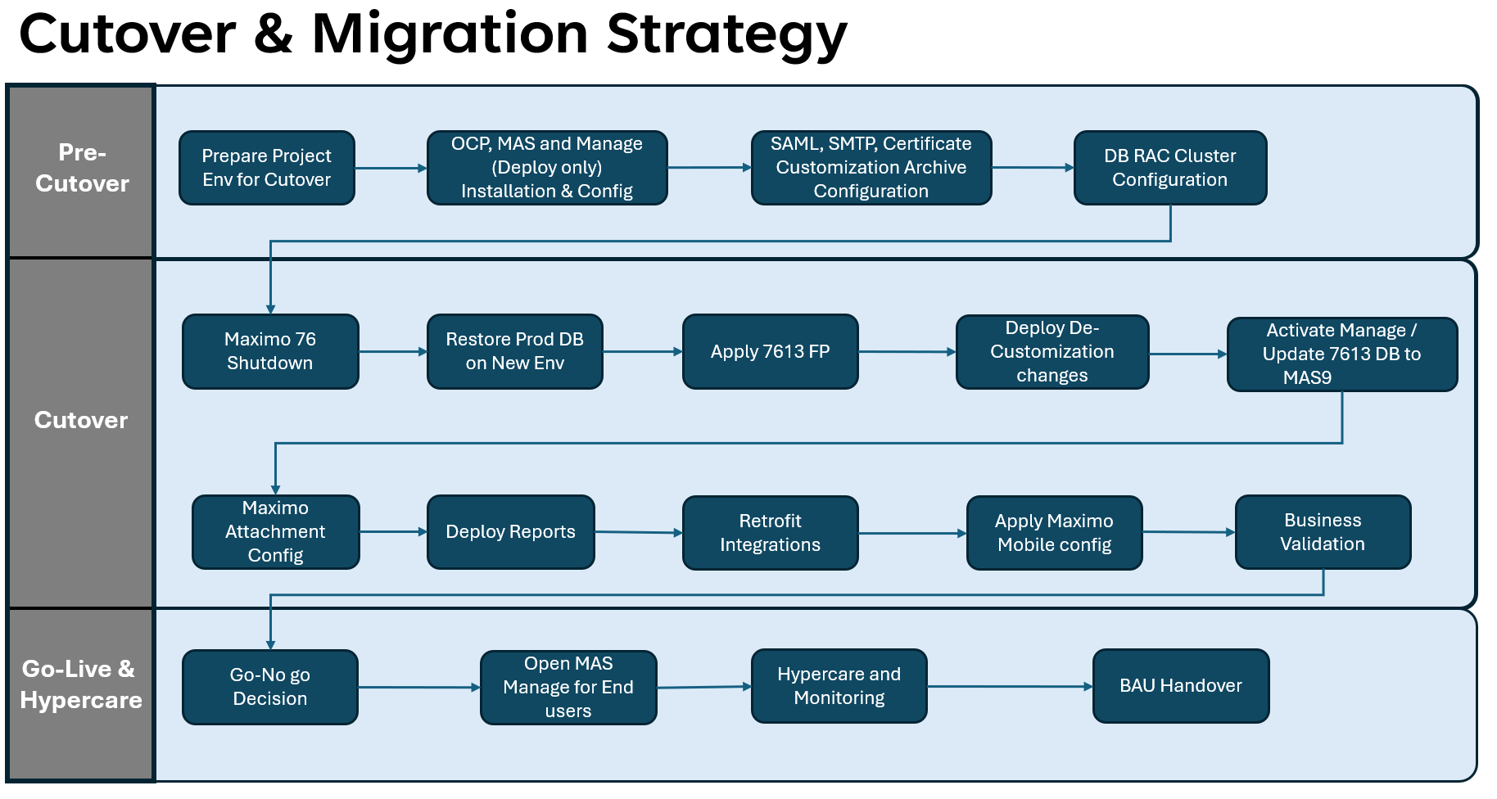

Throughout the project this cutover approach will be tested in 5 different cycles and each cycle the same steps will be executed. The cutover and migration plan will be improvised after each cycle and will be made final after Prod Rehearsal. Below diagram list all the cutover cycles and their purpose along with tentative timeline.

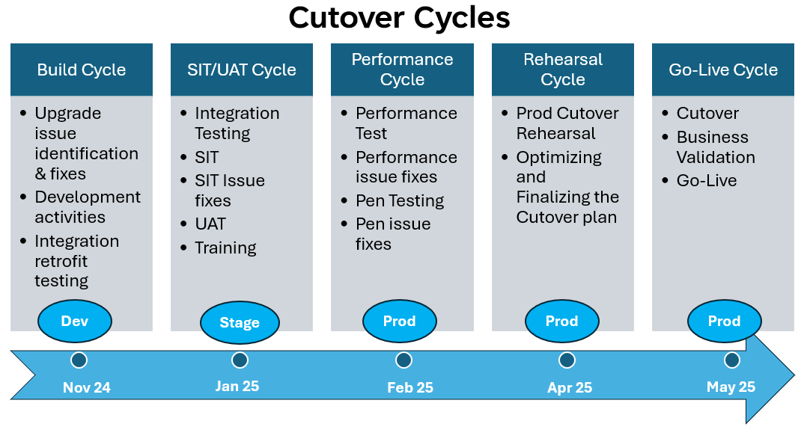

# Network & Security

## Network View

Azure RedHat OpenShift (ARO) will be created as a private cluster which means the API and Ingress visibility will be private.

|  |  |
| --- | --- |
| **Azure Component** | **Value** |
| Subscriptions | fortum-app-fomax |
| Region | West Europe |
| Resource Groups | **Prod** - fomax-e1-prod-rg **Stage & Dev** - fomax-e1-stage-rg **JumpBox** - fomax-e1-central-rg |
| Domain | **Prod** - fomax.fortum.com **Stage** - stage.fomax.fortum.com **Dev** - dev.fomax.fortum.com **Vanilla** - vanilla.fomax.fortum.com |
| CIDR | PODCIDR - 172.16.0.0/16  SERVICECIDR - 172.30.0.0/16 |
| Load Balancers | OpenShift Ingress controller |
| Vnet and Subnet | Vent is already created and just subnets needed for each cluster |
| Network Security Groups (NSGs) |
| Private Link | New one will be created manually for each cluster |
| Azure ExpressRoute | Existing One |

## Security View

## Azure Front Door & WAF

Azure Front Door & WAF will be configured for CDN and to protect Maximo application from common vulnerabilities and attacks (e.g., SQL injection, cross-site scripting).

We have different WAF Policies for each environment:

[la001474fomaxe1devwaf](https://portal.azure.com/?feature.msaljs=true#@fortum.onmicrosoft.com/resource/subscriptions/7d74e802-3a80-4036-a748-982d3d134748/resourceGroups/cd-hub-networking-e1-prod-rg/providers/Microsoft.Network/frontdoorWebApplicationFirewallPolicies/la001474fomaxe1devwaf) -> MAS Dev

[la001474fomaxe1stgwaf](https://portal.azure.com/?feature.msaljs=true#@fortum.onmicrosoft.com/resource/subscriptions/7d74e802-3a80-4036-a748-982d3d134748/resourceGroups/cd-hub-networking-e1-prod-rg/providers/Microsoft.Network/frontdoorWebApplicationFirewallPolicies/la001474fomaxe1stgwaf) -> MAS Stage

[la001474fomaxe1prdwaf](https://portal.azure.com/?feature.msaljs=true#@fortum.onmicrosoft.com/resource/subscriptions/7d74e802-3a80-4036-a748-982d3d134748/resourceGroups/cd-hub-networking-e1-prod-rg/providers/Microsoft.Network/frontdoorWebApplicationFirewallPolicies/la001474fomaxe1prdwaf) -> MAS Prod

As part of the testing, we have identified few rules which were blocking the connections/request from Maximo Mobile, hence we have changed below rules to put it on logging mode only. And this has been implemented in all three environments.

Microsoft_DefaultRuleSet-2.1-RFI-931130 -

Microsoft_DefaultRuleSet-2.1-SQLI-942100 -

Microsoft_DefaultRuleSet-2.1-SQLI-942430 -

Microsoft_DefaultRuleSet-2.1-SQLI-942340 -

Microsoft_DefaultRuleSet-2.1-SQLI-942200 -

Microsoft_DefaultRuleSet-2.1-SQLI-942370 -

Microsoft_DefaultRuleSet_2.1-MS-ThreatIntel-SQLI-99031002 -

Microsoft_DefaultRuleSet_2.1-PROTOCOL-ENFORCEMENT-920300 -

Microsoft_DefaultRuleSet_2.1-RCE-932115 -

Microsoft_DefaultRuleSet_2.1-SQLI-942380 -

Microsoft_DefaultRuleSet_2.1-SQLI-942120 -

Microsoft_DefaultRuleSet_2.1-MS-ThreatIntel-SQLI-99031001 -

Microsoft_DefaultRuleSet_2.1-MS-ThreatIntel-SQLI-99031004 -

Microsoft_DefaultRuleSet_2.1-Java-944240 -

Microsoft_DefaultRuleSet-2.1-XSS-941320 -

Microsoft_DefaultRuleSet-2.1-RFI-931120 -

Microsoft_DefaultRuleSet-2.1-General-200002 -

Microsoft_DefaultRuleSet-2.1-XSS-941330 - stg,dev,prd

Microsoft_DefaultRuleSet-2.1-XSS-941340 - stg,dev,prd

Microsoft_DefaultRuleSet-2.1-SQLI-942210 - stg,dev,prd

Microsoft_DefaultRuleSet-2.1-SQLI-942180 - stg,dev,prd

Microsoft_DefaultRuleSet-2.1-PROTOCOL-ENFORCEMENT-920271 - stg,dev,prd

Microsoft_DefaultRuleSet-2.1-PROTOCOL-ENFORCEMENT-920230 - stg,dev,prd

Microsoft_DefaultRuleSet-2.1-PROTOCOL-ENFORCEMENT-920220 - stg,dev,prd

Microsoft_DefaultRuleSet-2.1-XSS-941180 - stg,dev,prd

Microsoft_DefaultRuleSet-2.1-SQLI-942330 - stg,dev,prd

Microsoft_DefaultRuleSet-2.1-XSS-941310 - stg,dev,prd

Microsoft_DefaultRuleSet-2.1-PROTOCOL-ENFORCEMENT-920270, stg,dev,prd  
Microsoft_DefaultRuleSet-2.1-PROTOCOL-ENFORCEMENT-920320, prd,dev,stg

Microsoft_DefaultRuleSet-2.1-PROTOCOL-ENFORCEMENT-920340, prd,dev,stg

Microsoft_DefaultRuleSet-2.1-PROTOCOL-ENFORCEMENT-920341, prd,dev,stg

Microsoft_DefaultRuleSet-2.1-PROTOCOL-ATTACK-921110, prd,dev,stg

## Azure Private Link

Azure Private link will be configured to access Maximo application over private network.

## Azure Firewall

Azure Firewall will be configured to protect the ARO network by inspecting and filtering traffic.

## Authentication

Maximo Application Suite will be integrated with Fortum Active Directory for Single Sign-on. Maximo Users will be synced to MAS from Active Directory groups to MAS on periodic basis. All users will have MFA enabled to log into Maximo. There may be few generic users who may be exempted from MFA if Fortum organization policies allows it. Also, all inbound integrations will need to be authenticated against Maximo using API keys.

Database – Existing setup will follow as there won't be any change in architecture and process of database management as part of this project. Below high-level diagram explaining authentication and authorization to DB servers which is already in place.

## Authorization

Authorization for MAS Manage will be managed through Maximo Security Groups in Manage application as per the current process in Maximo 7612.

## Encryption

#### Data at rest

Maximo DB will be by default encrypted by MAS at rest and need encryption keys to restore the backups, these encryption keys will be stored in OpenShift Secrets.

#### Data in Transit

All the data in transit will be secured by TLS certificates.

# Service Overview

## Support Model



## Service Level Agreements

Fortum Maximo 7 is a C1 kind of application. Here are the SLAs.

* DR SLA
  + RTO  < 48 Hours
  + RPO < 24 Hours
* Availability SLA of Maximo – 24/7

**Application SLA**

|  |  |  |
| --- | --- | --- |
| **Service Level Requirement** | **Unit** | **C1** |
| Support time | EET (UTC+2) | 24/7 |
| Service time for monitoring and control | EET (UTC+2) | 24/7 |
| Service time for Incident management | EET (UTC+2) | 24/7 |
| Response Time | Hours (during Support time) | 1 |
| P1 Resolution Time | Hours (during Support time) | 4 |
| P2 Resolution Time | Hours (during Support time) | 8 |
| P3 Resolution Time | Hours (during Support time) | 16 |
| P4 Resolution Time | Hours (during Support time) | 40 |

**DB SLA**

## Maintenance and Patching/Release Process

## Azure RedHat OpenShift

Red Hat releases minor versions of Red Hat OpenShift Container Platform (OCP) approximately every four months. These releases include new features and improvements. Patch releases are more frequent (typically weekly) and may include fixes for security vulnerabilities or bugs.

Azure Red Hat OpenShift is built from specific releases of OCP. This article covers the versions of OCP that are supported for Azure Red Hat OpenShift and details about updates, deprecations, and the support policy.

Red Hat OpenShift Container Platform uses semantic versioning. Semantic versioning uses different levels of numbers to specify different versions. The following table illustrates the different parts of a semantic version number, in Fortum, ARO version 4.15.27 has been considered.

* **Major version**: No major version releases can be considered cause there is compatibility matrix which MAS version follows with OCP. Hence any major version upgrade for OCP has to be in-line with MAS upgrade.
* **Minor version**: Released approximately every four months by Azure. Minor version updates can include feature additions, enhancements, deprecations, removals, bug fixes, security enhancements, and other improvements. These minor versions can be considered for critical bug fixes or vulnerabilities. But this needs to be tested thoroughly on lower environments before Prod release.
* **Patch version**: Typically released each week, or as needed. Patch version updates can include bug fixes, security enhancements, and other improvements. Again, this should be considered only for critical bug fixes or vulnerabilities. But this needs to be tested thoroughly on lower environments before Prod release

Update channels are the mechanism by which users state the OpenShift Container Platform minor version they intend to update their clusters to. Update channels are tied to a minor version of Red Hat OpenShift Container Platform.

For Fortum, the update channel will not be configured to avoid the automatic updates to OCP platform, any version upgrade needs to be assessed critically and tested on lower environments as per need.

In extreme circumstances and based on the assessment of the CVE criticality to the environment, a critical patch update may be applied to clusters automatically by Azure Red Hat OpenShift Site Reliability Engineers (SRE) which will then be followed with a notification informing you of the change. It's best practice to install patch (z-stream) updates as soon as they're available.

Below table shows the end of life of ARO versions. Fortum is on 4.15.27, hence minor version upgrade needs to be considered before June 2025.

## Maximo Application Suite -

IBM Long-Term Support version delivery model for MAS which is explained below. IBM has introduced the Long-Term Support for MAS under Continuous Delivery support model. MAS 9 has been designated the LTS release and this is the version is considered for Fortum Maximo upgrade project. Below diagram explains the future MAS releases and LTS support for different MAS versions from version 8.9

MAS9 version is supported until Jun 2027 with option to extend it till July 2031 under 3+1+3 release support.

## Change Management

Existing Change Management process will be followed for ARO, Maximo and Database for all kinds of changes to any solution components.

## Backup Schedule

Maximo Application Suite on OpenShift will have different solution components which can be backed up, but backup policy will be designed based on the Fortum’s DR requirements.

* MongoDB for Maximo Application Suite **– Backup Considered**
* Maximo Application Suite core
  + IBM Maximo Operator Catalog – **Not considered as it would be reprovisioned in DR scenario**
  + IBM Suite License Service license file and ID – **One time backup/safe storage**
  + Maximo Application Suite core namespace – **Not considered as it would be reprovisioned in DR scenario**
* Maximo Manage
  + Maximo Manage databases **– Backup Considered**
  + Maximo Manage namespace – **Not considered as it would be reprovisioned in DR scenario**
  + Maximo Manage attachments **– Backup Considered**
  + Maximo Manage Custom Archive **– Backup Considered**

**Application Backup –**

Below is proposed backup schedule for different MAS Solution components.

|  |  |  |  |  |  |
| --- | --- | --- | --- | --- | --- |
| **Application Component Backup (VANILLA, DEV, STAGE and PROD)** | | | | | |
| **Components** | **Schedule** | **Retention Period** | **Location** | **Storage** | **Ownership** |
| MongoDB | Weekly | 90 days for weekly | /home/prod_bkp/mongodb | VM az001474de1va08 | Maximo AMS Team |
| Custom Archive | No Backup needed as this may never change again, and it is available to download from git repository (path can be found in MAS configuration). Also the Archive file has been handed over to AMS team to maintain. | | | | Maximo AMS Team |
| Attachments, logs, JMS Store, Global Directory | Daily | 30 days | Azure Files | Azure Files | PCM Team |

To ensure business continuity and data protection for Fortum's Maximo application deployed on Azure Red Hat OpenShift (ARO), a robust backup strategy for Azure Files to be implemented. The includes the following key steps:

1. **Setup Azure Backup**:
   * Create a Recovery Services Vault in Azure to store backup data.
   * Enable backup for Azure File Shares and select the storage account.
2. **Backup Policy**:
   * **Frequency**: Daily backups for frequently changing data and weekly full backups for archival purposes.
   * **Retention**: Daily backups retained for 42 days and weekly backups for 90 days.
   * **Storage**: Use Geo-Redundant Storage (GRS) for durability and geographical redundancy.
3. **First Backup**:
   * Initiate the first manual backup to confirm proper configuration.

This ensures that Fortum's Maximo application data is protected, with automated backups and efficient recovery options in place to support rapid data restoration and minimize downtime.

**Database Backup –**

Below is proposed backup schedule for different MAS Solution components. This is based on same backup schedule what is there currently for Maximo 76 Databases.

|  |  |  |  |  |  |
| --- | --- | --- | --- | --- | --- |
| **DB Backup & Retention (VANILLA, DEV, STAGE and PROD)** | | | | | |
| **Schedule** | **Archive Backups** | **Retention Period** | **Location** | **Storage** | **Ownership** |
| Daily 12:00AM to 2:00 AM | YES, every 15 mins | 45 days | OCI Cloud | OCI Public cloud Object Storage | Oracle Cloud team |

## Disaster Recovery

Fortum Maximo Solution components majorly have 2 components –

* MAS Application on Azure RO
* MAS Manage DB on OCI

RTO and RPO for application and DB are –

|  |  |  |  |
| --- | --- | --- | --- |
| **Sr No** | **Solution Component** | **RTO** | **RPO** |
| 1 | Application | 48 hours | 24 Hours |
| 2 | Database | 2 Hours | 15 Mins |
| **Combined SLA** | | **48 Hours** | **24 Hours** |

Below table explains the Fortum Maximo Solution’s different disaster scenarios along with their recovery plan at high-level.

|  |  |  |  |
| --- | --- | --- | --- |
| **Disaster Scenario** | **Description** | **Impact** | **Recovery Plan** |
| **Zone Failure** | Failure of a single Availability Zone within the ARO region. | Reduced availability: workloads in the affected zone may be temporarily down. | ARO is zone redundant and in case of zone failure, ARO automatically balances and can restart affected nodes. But to support the application load we can add more nodes to available zones |
| **Node Failure** | Failure of one or more cluster nodes due to hardware or software issues. | MAS application components on the failed nodes may be temporarily unavailable. | For virtualized OpenShift clusters, the hypervisor’s high availability features can bring back nodes quickly. This will result in the pods on any lost OpenShift nodes being rescheduled when the node rejoins the cluster But In case it does not come back then follow either of the below steps - Replace the failed node with new health node - Add new worker node to the cluster |
| **Cluster Control Plane Failure** | Loss of connectivity or function in the ARO control plane, affecting cluster management. | Limited ability to deploy/manage resources, but existing workloads run. | ARO will have 3 control planes and Azure manages the control plane; monitoring systems alert Azure engineers for fast mitigation; generally resolved within Azure SLAs. |
| **Network Outage** | Network failure between users and the ARO cluster or within Azure regions. | Limited access to MAS or may not be available | Restore Network, if needed work with Azure or RedHat support |
| **Data Corruption** | Accidental or malicious corruption of data within applications or storage. | Limited or no application availability | Restore DB from backup, for more information please check backup section of this document |
| **Complete Region Failure** | Outage impacting the entire Azure region where the ARO cluster is hosted. | MAS application and data in the region become unavailable. | Rebuild entire application on different Azure region. Use terraforms scripts to enable fast deployment of cluster and manually restore application components from backup |
| **Persistent Volume Loss** | Loss of storage volume where application data is stored, potentially due to storage failure or corruption. | Maximo Manage doclinks feature will not be available | Azure Files is zone redundant |

## Application High-Availability on ARO

Azure Red Hat OpenShift provides highly available, fully managed OpenShift clusters on demand, monitored and operated jointly by Microsoft and Red Hat. Azure ARO utilizes three availability zones, and it is zone redundant. All nodes of OpenShift cluster including Control, Worker and Infra Nodes will be distributed amongst the 3-availability zone as shown in the below figure.



## Database High-Availability on ARO

Fortum using with OCI public cloud with two data centre OCI (Region -1 Amsterdam and Region -2 Frankfurt), Maximo databases SIT and Production database are running on two nodes in RAC (Oracle Real application Clusters) mode.

Automatic Failover Mechanisms (DR) is enabled If an instance becomes unresponsive, Oracle RAC triggers an automatic failover, redirecting traffic to other healthy instances. This ensures that applications keep running without interruption.

Maximo Development and Trainings DB are using with NON-RAC and Service Recovery Process (SRP) is configured at infra level backups. We can minimize down time for host and DB recovery in case anything happened at host level.

Below picture shows the current setup on Maximo Prod DB cluster which will be continued for MAS as well.



## DR Testing

It is recommended to plan annual DR testing, but this is currently out of scope for this project, also revising DR SLA should be re-considered in future as current RTO is 48 hours which is too high for Maximo application.

## Monitoring Solutions

Monitoring will include two major components of solution –

1. Azure RedHat OpenShift Platform Monitoring
2. Maximo Application Suite Monitoring

## Azure RedHat OpenShift Platform Monitoring

For data collection within ARO, we’ll deploy Prometheus directly inside ARO to gather container, node, and application metrics as described below. The intention is to forward these metrics to Azure Monitor for Containers by leveraging Prometheus exporters. Azure Monitor’s Log Analytics workspace will serve as a centralized data repository, which can then seamlessly integrate with the LKM monitoring service. This will be validated and implemented accordingly once Dev cluster is up and running. But we can see this information from ARO Prometheus dashboard at least.

**Monitoring Stack Deployment**: We’ll be using **Prometheus within ARO** because It allows for more efficient metric collection and auto-discovery within the ARO environment and reduce network overhead.

Monitoring configuration will be done from azure side to monitor the key parameters as explained in below table. This will be included as part of standard monitoring within CloudOps LKM Monitoring.

Azure Red Hat OpenShift Cluster

Prometheus Exporter on ARO

Azure Monitor

CloudOps ELK Monitoring

**Key Metrics for Azure Monitor for Containers**

|  |  |  |
| --- | --- | --- |
| Metric Category | Key Metrics | Description |
| Container Insights | CPU Usage | Measures the percentage of CPU utilized by containers. |
| Memory Utilization | Tracks the amount of memory being used by containers. |
| Disk I/O | Monitors read and write operations on the disk. |
| Node Metrics | Node CPU Usage | Percentage of CPU usage across all nodes. |
| Node Memory Usage | Amount of memory used on each node. |
| Node Disk Space Available | Remaining disk space on each node. |
| Pod Health | Pod Status | Current state of the pod (Running, Pending, Failed). |
| Restart Count | Number of times a pod has restarted, indicating potential issues. |
| Network Performance | Network Traffic | Monitors incoming and outgoing traffic for the cluster. |
| Latency | Measures the response time of network requests. |
| Custom Application Metrics | Application-specific metrics | Custom metrics defined by the application, like transaction counts or error rates. |
| Application and OCP URLS | URL Availability | Monitoring the application URLs for liveness |

## Maximo Application Suite Monitoring

Maximo Application Suite applications provide application-level metrics and dashboards for monitoring various aspects for application health and performance. Maximo Application Suite uses the Prometheus monitoring stack within OCP for storing application level metrics. Maximo Application Suite also uses Grafana for rendering application-level metrics in integrated dashboards.

Below are some key parameters of Manage applications that can be configured, and alerts can be created accordingly for each of the metrics. Additional metrics or alerts can be configured as per need.

|  |  |
| --- | --- |
| Key Metrics | Description |
| DB Connections | Manage open DB connections |
| JVM heap | Manage Pod JVM heap size |
| MBO Count | Manage Open MBOSET and MBO Count |
| Concurrent Users | Manage Concurrent users |
| Sessions | Manage User sessions |
| Pod CPU | Manage Pod CPU utilization |
| Pod Memory | Manage Pod Memory utilization |

# Decommissioning

Below picture explains the high-level plan of Project environments along with the timeline when it needs to be decommissioned. Maximo 7612 will be decommissioned towards end of the warranty support.

Attached file details all the components which needs to be decommissioned along with responsible team.

[DecommissionPlan.xlsx](https://fortum.sharepoint.com/:x:/r/sites/FortumMaximoMAS8Upgrade-DesingofFunctionalities/Shared%20Documents/Building%20the%20MAS%20version/DecommissionPlan.xlsx?d=w6525f770efc04358994b72cc4a3fc2ff&csf=1&web=1&e=GRGXzA)

# Appendix